Name: Hardik Patel
Std Id : 202103032

- Given an array, rotate the array of size N by M position in the clockwise direction. N = 5,M=3 A[ ]={1,2,3,4,5} Output = {3,4,5,1, 2}

Code:

package com.DSA;
import java.util.Scanner;
public class Exercise1 {
static Scanner in = new Scanner(System.in);
public static void main(String[] args) {
Exercise1 rotate = new Exercise1();
int[] arr = { 1, 2, 3, 4, 5 };
int position = in.nextInt();
position--;
rotate.Change(arr, position, arr.length);
for (int j : arr) System.out.print(j + " ");
}
void Change(int[] arr, int index, int length)
{
for (int i = 0; i < index; i++)
swap(arr, length);
}
void swap(int[] arr, int length)
{
int i, temp;
temp = arr[0];
for (i = 0; i < length - 1; i++)
arr[i] = arr[i + 1];
arr[length-1] = temp;
}
}
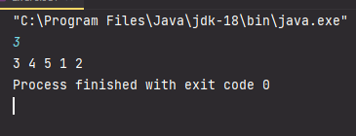
Output :

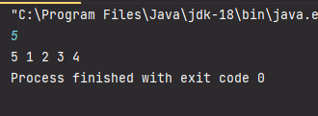
- In the BTech MnC branch, there are 47 students, who are studying 6 subjects in Semester 2. Prepare an array named Test which stores the marks from 0 to 100. Write a program which a. Finds the average marks for each subject b. Find the percentage obtained by each student c. Find the number of students who failed in each subject (individually) d. Find the number of students who have failed in more than 2 subjects e. Find the mean and median of the class performance You need to create a random marks generator function that will input the marks in the range [0,100]
Code:

package com.DSA;
import java.util.Scanner;
public class Exercise2 {
static Scanner in = new Scanner(System.in);
public static void main(String[] args) {
System.out.println("Enter the total number of Subject : ");
int num = in.nextInt();
System.out.println("Enter the total number of students : ");
int st = in.nextInt();
int[][] arr = new int[st][num];
System.out.println("Enter the marks in each subject ");
for(int i=0;i < st;i++)
{
for (int j = 0; j < num; j++) {
arr[i][j] = in.nextInt();
}
}
int sum = 0;
for(int i=0;i<st;i++)
{
for (int j = 0; j < num ;j++) {
sum = sum+arr[i][j];
}
}
System.out.println("Average marks : " + sum/num);
System.out.println("The total marks is : " + sum);
float percentage = (sum / (float)num);
System.out.println( "Percentage : " + percentage + "%");
}
}

Output:
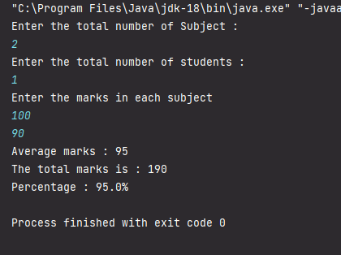
- In a competitive exam, 80 questions were asked. Negative marks were also given for wrong answers. The marks obtained per question are in the range of [-5,20]. Given a sequence of A(1) ...A(80), give an algorithm for finding a contiguous subsequence A(i) ... A(j) for which the sum of marks in the subsequence is maximum. You can create a random marks generator function that will input the marks in the range [-5,2 ]

Code:
package com.DSA;
import java.util.Random;
public class Exercise3 {
public static void main(String[] args) {
Random objGenerator = new Random();
int[] arr = new int[80];
System.out.println("Random No : ");
for (int i = 0; i< 80; i++){
int randomNumber = objGenerator.nextInt(-5,20);
arr[i] = randomNumber;
System.out.print(randomNumber + " ");
}
int n = arr.length;
maxSubArraySum(arr, n);
}
static void maxSubArraySum(int[] arr, int size)
{
int maximum = Integer.MIN_VALUE,
endingMax = 0,start = 0,
end = 0, s = 0;
for (int i = 0; i < size; i++)
{
endingMax += arr[i];
if (maximum < endingMax)
{
maximum = endingMax;
start = s;
end = i;
}
if (endingMax < 0)
{
endingMax = 0;
s = i + 1;
}
}
System.out.println("\nMaximum contiguous sum is "
+ maximum);
System.out.println("Starting index " + start);
System.out.println("Ending index " + end);
}
}
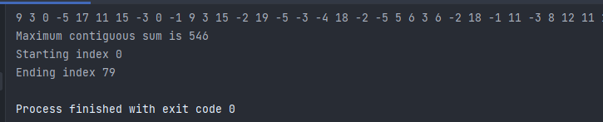
Output:

